Sports Photography: Specializing in customized team/event templates
Twenty 6” x 9” photos in black faux leather hard cover book
One small keyhole photo for cover
Combine multiple players and or multiple teams/divisions in one book
21 Picture Photo Book

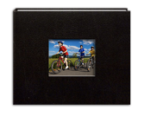
Pay for your photo book by email money transfer to lucy.fowler@nf.sympatico.ca

$60

#3
Order

Fill out the photobook order form listing your pictures and information

#1
Choose Pictures

Choose 21 photos Write down the picture numbers of each photo
(TLL-xxxx)

#2
Choose Cover

Decide which photo to use for the front keyhole cover and identify that picture

